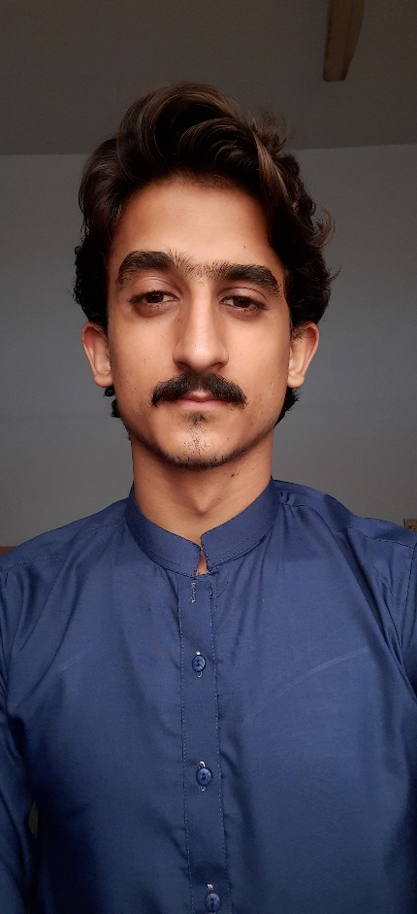

React

Wordpress

jQuery

BOOTSTRAP

JAVASCRIPT

CSS

HTML

**SKILLS**

Hi I am currently studying BSCS at Karachi University and recently completed my FSC I have been working as a front-end developer on fiver for 2 years I have experience in making responsive Web sites and Web pages I have completed over 6 projects for myself and have done many projects on fiver with 5-star ratings. I have Two and a half years of experience in front end development. I have good experience in many languages like (HTML, CSS, JavaScript, Bootstrap, jQuery, Sass). And from now on I have started learning (REACT JS) to and more power in my profession :)

**MY INTRO**

**UNIVERSITY OF KU**

**BACHELOR IN SOFTWARE ENGENERING**

**2022 - Present**



Music



Writing



Travel

**Hobbies**

**Phone:** 03463284296

**Email:** na3284296@gmail.com

**Education**

Front end Developer

Noman Afridi